**How to add/ update files in Github**

Contents

Add/ update file in your local machine 1

Add the files using command prompt 1

Commit your updates using command prompt 1

Then push to github 2

You can see the status using command 2

## Add/ update file in your local machine

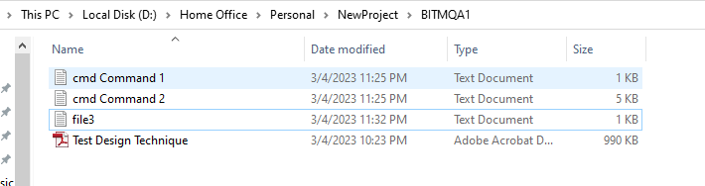

## Add the files using command prompt

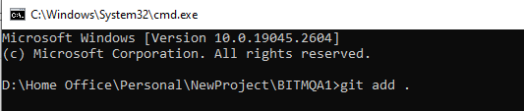

## Commit your updates using command prompt

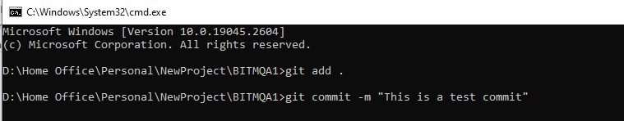

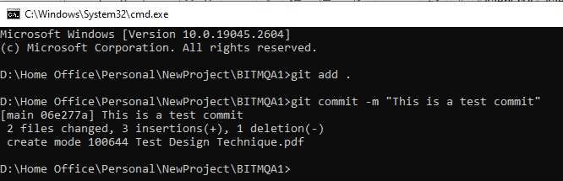

## Then push to github

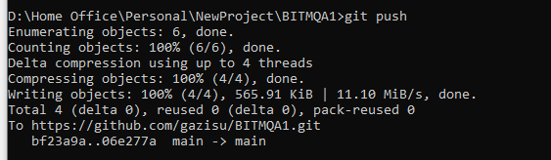

## You can see the status using command

